

**Discipline**

**«Database Management System»**

**Final Work**

**"Car Rental Services Database"**

**2nd year student**

**Specialty: "Digital Engineering"**

**Belov Anton**

**Checked:**

**Anarbekova T. M.**

**ALMATY**

**2024**

## Content

1. Introduction
2. Body
   1. Description of the subject area
   2. Stages of project implementation
      * Database development
      * Implementation of the server part
      * Client-side implementation
   3. Functionality testing
   4. Technology Usage Analysis
3. Conclusion
4. References
5. Application

## Introduction

### Brief description of the project

The project is the development of a web application — an admin panel for managing the car rental database. The app allows administrators to:

* manage car records (add, update, delete);
* keep records of customers;
* track bookings;
* manage payments;
* perform analytical operations, such as revenue calculation and statistics on vehicle status
* View all data in a shared table

This project is aimed at automating the processes of managing car rental data and is an example of the use of modern technologies to simplify routine tasks

### Goals and objectives of the project

**The goal of the project is to** create a functional and convenient application for database management that meets modern requirements.

**Tasks:**

1. Develop a database structure.
2. Implement a backend to handle requests.
3. Create a front-end using HTML, CSS, and JavaScript.
4. Ensure correct integration between the client and server parts.
5. Test your app for compliance.
6. Analyze the technologies used and their effectiveness.
7. Consider possible scenarios for expanding the functionality of the application.
8. Evaluate the usability of the interface by end users.
9. Ensure that the application has the performance it needs when processing large amounts of data.

### Topicality

The application is relevant for car rental companies, as it allows you to effectively manage data and automate processes. In today's business environment, the effectiveness of data management has a direct impact on a company's competitiveness

The use of digital solutions allows:

* reduce labor costs for data processing
* Minimize the chance of data errors
* speed up the decision-making process

### Object of research

Car rental database that includes the following entities: cars, customers, bookings, and payments

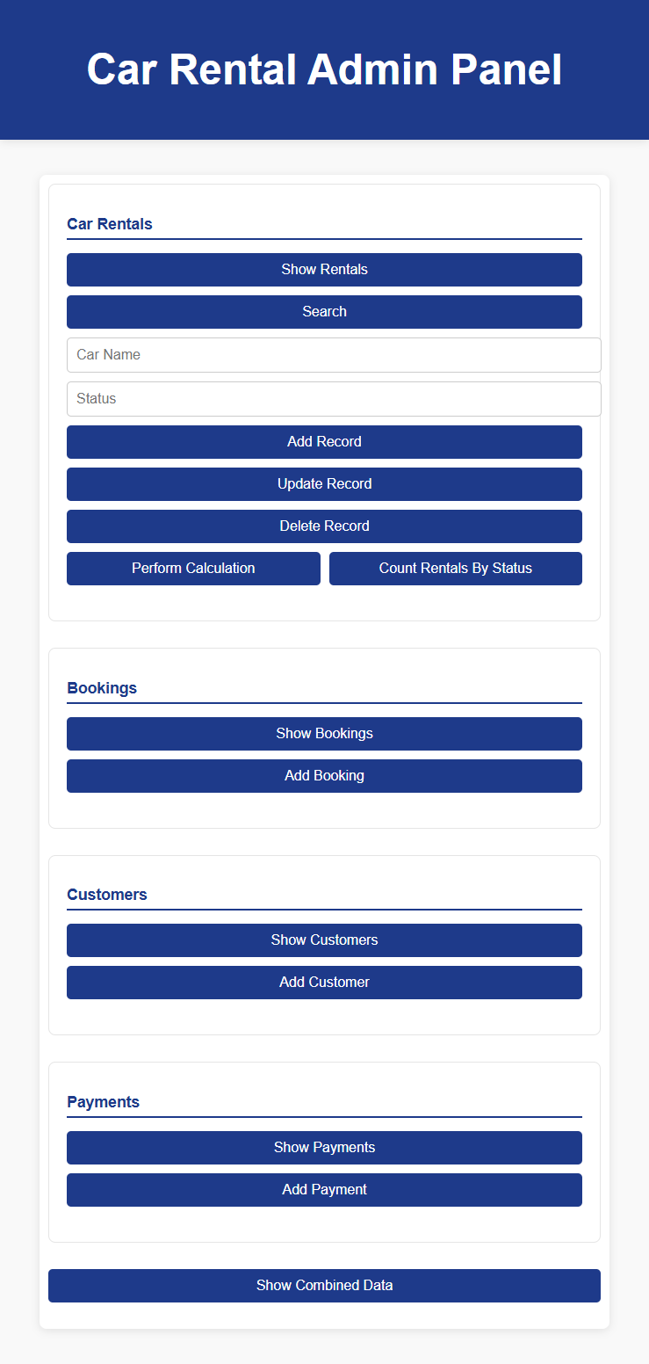

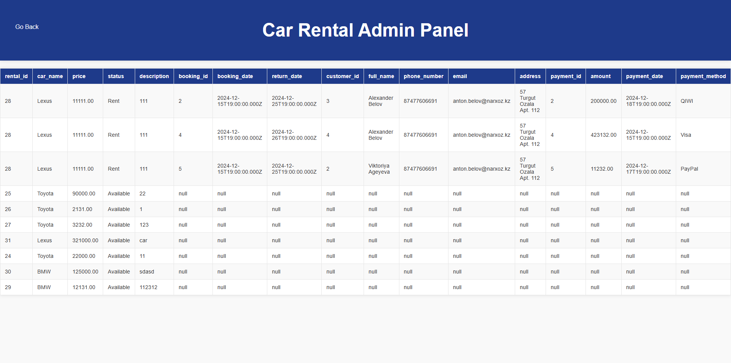

### INVESTIGATIONS

The following methods were used in the process of work:

* Analysis of domain requirements
* Database design based on normalization
* Development of server and client parts using modern technologies
* Testing the finished application to verify functionality
* System performance analysis
* Evaluate the usability of the interface based on user feedback

## Body

### 1. Description of the subject area

The car rental database should include the following information:

* **Cars:** name, rental price, status (available, rented), description
* **Clients:** full name, contact details, address
* **Reservations:** communication between customers and cars, booking and return dates
* **Payments: Information** about linked bookings, amounts and payment methods

This information is stored in a PostgreSQL relational database. Integrity constraints and foreign keys are applied to ensure data integrity

#### Requirements Analysis

To build the system, the following aspects were analyzed:

* Interface usability requirements
* Ability to perform analytical operations
* Customer data security

### User interface requirements

* Simple and intuitive design
* Availability of division into sections (cars, customers, bookings, payments)
* Ability to perform CRUD operations with minimal time
* Feedback to the user in case of errors
* Support for displaying data in tabular form for easy analysis
* Interface flexibility to add new features in the future

### Expected results of work

As a result of the project:

1. The user will be able to perform basic data management operations through a user-friendly interface
2. Data processing time will be significantly reduced through automation
3. A high degree of data protection will be achieved through the implementation of checks and constraints at the database level

### 2. Stages of project implementation

#### 2.1. Development of the database

A database with the following tables was created for the project:

* **rentals** (id, car_name, price, status, description)
* **customers** (id, full_name, phone_number, email, address)
* **bookings** (id, customer_id, rental_id, booking_date, return_date)
* **payments** (id, booking_id, amount, payment_date, payment_method)

Relationships between tables are implemented through foreign keys. An ER diagram was created to visualize the database structure (see Appendix)

#### Detailed description of tables

1. **Таблица rentals:**
   * Contains information about cars available for rent.
   * Fields: id (unique identifier), car_name (car name), price (rental price), status (current status of the car), description (description)

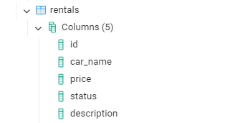

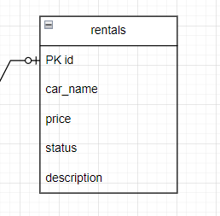

1. **Таблица customers:**
   * Stores data about the company's customers.
   * Fields: id (unique identifier of the client), full_name (full name of the client), phone_number (phone number), email (email), address (address of residence)

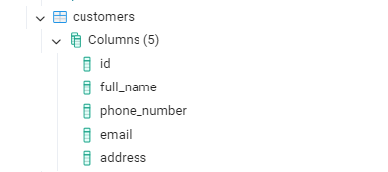

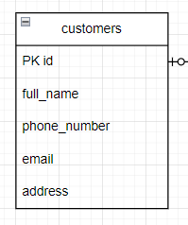

1. **Таблица bookings:**
   * Connects customers and vehicles by providing booking information.
   * Fields: id (unique identifier of the booking), customer_id (link to the client), rental_id (link to the vehicle), booking_date (date of booking), return_date (date of return)

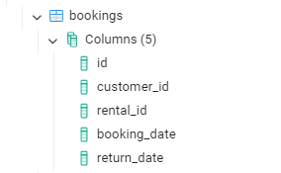

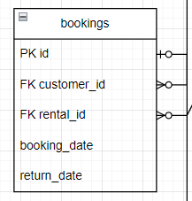

1. **Таблица payments:**
   * Responsible for accounting for payments
   * Fields: id (unique payment ID), booking_id (booking link), amount (payment amount), payment_date (payment date), payment_method (payment method)

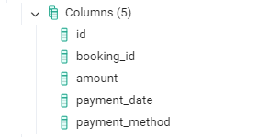  
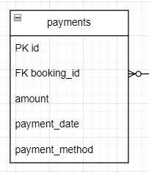

#### SQL queries

Example of creating a table:

CREATE TABLE rentals (

id SERIAL PRIMARY KEY,

car_name VARCHAR(255),

price NUMERIC,

status VARCHAR(50),

description TEXT

);

Example of adding data:

INSERT INTO rentals (car_name, price, status, description)

VALUES ('Toyota Corolla', 1500, 'Available', 'Compact sedan');

An example of joining all tables into one via a JOIN table:

SELECT

rentals.id AS rental_id, rentals.car_name, rentals.price, rentals.status, rentals.description,

bookings.id AS booking_id, bookings.booking_date, bookings.return_date,

customers.id AS customer_id, customers.full_name, customers.phone_number, customers.email, customers.address,

payments.id AS payment_id, payments.amount, payments.payment_date, payments.payment_method

FROM rentals

LEFT JOIN bookings ON rentals.id = bookings.rental_id

LEFT JOIN customers ON bookings.customer_id = customers.id

LEFT JOIN payments ON bookings.id = payments.booking_id

### 3. Functionality testing

The app has been tested on:

* correctness of CRUD operations (adding, updating, deleting);
* performing filtering and aggregations (for example, searching for cars by status);
* Correct display of data in tables.

#### Test results

**Function**

Adding a car



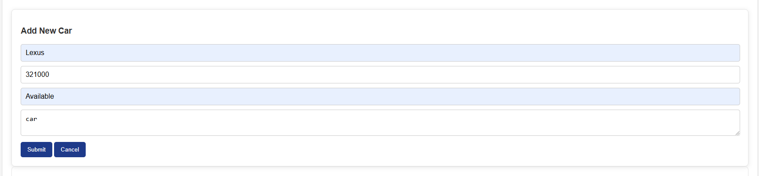

**Actual result**





Record added successfully

**Expected result**

Successfully

**Function**

Filtering by Status



**Actual result**

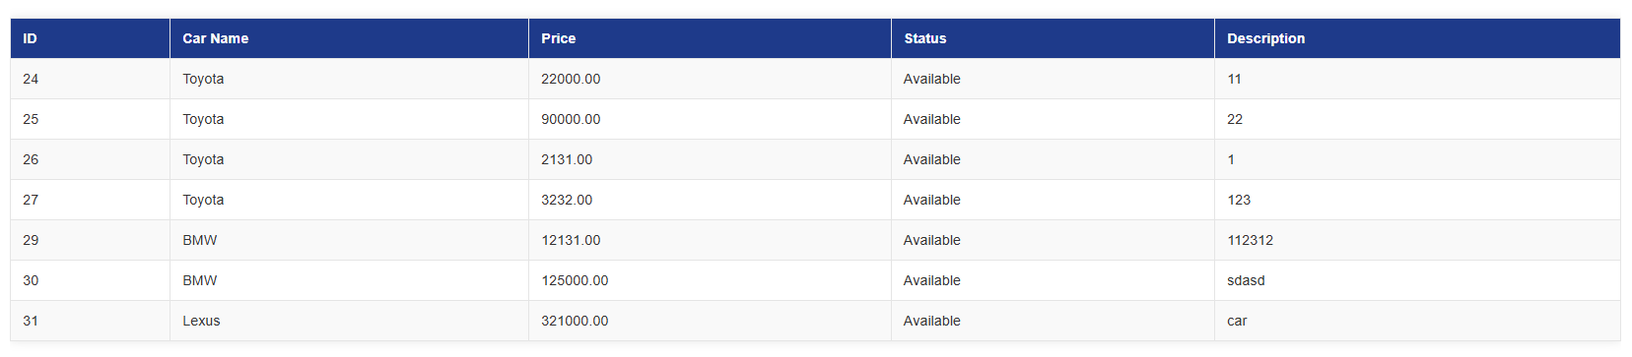

Only available cars are returned

**Expected result**

Successfully

**Function**

Calculating the total cost



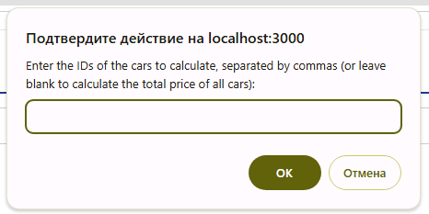

**Actual result**



Correct amount result

**Expected result**

Successfully

**Function**

Editing data from a pre-made table with ID selection

 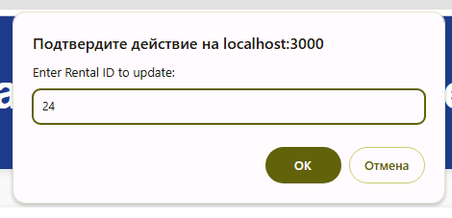 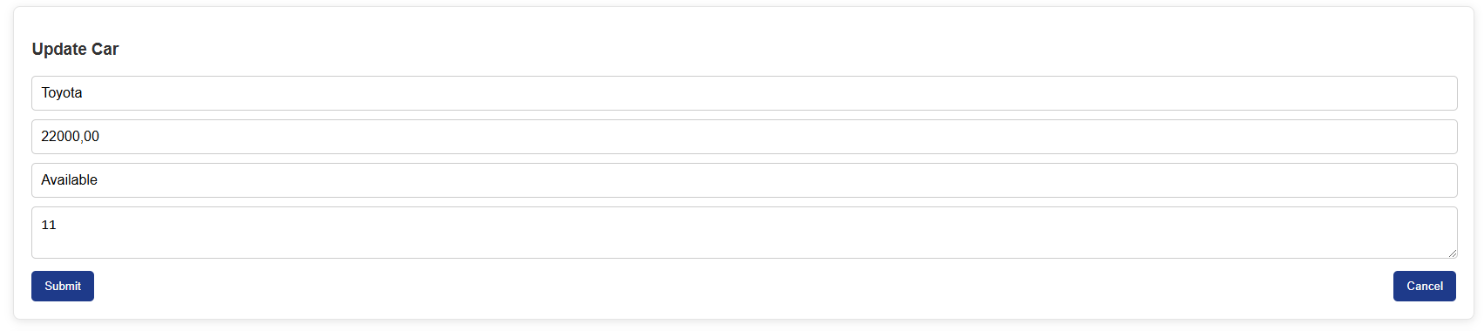

**Actual result**

We will change the price to +300$





Correct result of changing the data of the selected table





**Expected result**

Successfully

### 4. Analysis of the use of technology

#### Server part

The server application is implemented using the **Node.js platform**  and Express.js framework. These technologies were chosen for their flexibility, scalability, and broad support from the developer community.

**Main advantages:**

1. Process requests quickly with an asynchronous I/O model.
2. Easy integration with the PostgreSQL database via the pg library.
3. The ability to easily expand the functionality due to a variety of modules.

Example of server-side endpoint implementation:

Javascript

app.post('/rentals', async (req, res) => {

const { car_name, price, status, description } = req.body;

const result = await pool.query(

"INSERT INTO rentals (car_name, price, status, description) VALUES ($1, $2, $3, $4) RETURNING *",

[car_name, price, status, description]

);

res.status(201).json(result.rows[0]);

});

#### Client side

The client part is developed using HTML, CSS, and JavaScript. The main functionality is based on the use of **the Fetch API** to send HTTP requests to the server and dynamically display data on the page.

**Advantages:**

1. Intuitive interface with minimalistic design
2. Dynamic data loading, which improves app responsiveness
3. Easy integration with the backend

An example of calling the fetchData function to get booking data:

Javascript

fetchData('/bookings', 'GET').then(data => {

displayTable(data, 'bookings');

});

#### Database

**PostgreSQL** was chosen as a database based on its data-intensive capabilities, transaction support, and robust data integrity mechanisms.

Example of using aggregate functions:

Sql

SELECT status, COUNT(*) AS count

FROM rentals

GROUP BY status;



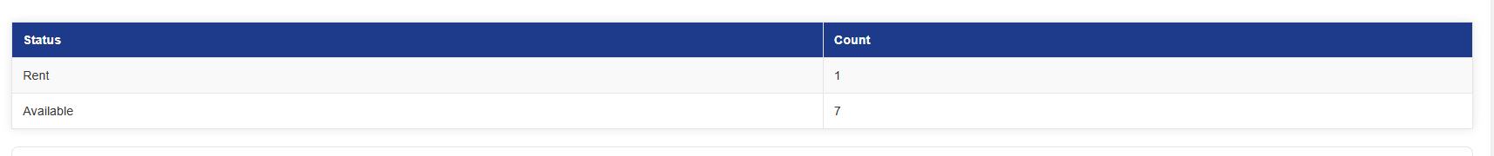

**Advantages of PostgreSQL:**

1. Support for complex SQL queries, including nested queries.
2. Scalable to work with large amounts of data.
3. High performance in transaction processing.

## Conclusion

### Project results

Within the framework of the project, a system was developed to manage the car rental database. The admin panel provides full functionality for working with data, including adding, updating, deleting records, and performing analytical operations.

**Main achievements:**

1. The database structure has been implemented taking into account normalization and relationships.
2. A server has been developed that supports all major CRUD operations.
3. A user-friendly interface has been created for users to interact with data.

### Development prospects

1. **Security:** Implement authentication and authorization to protect data
2. **Data visualization:** Add graphs and charts to analyze revenue and bookings
3. **Multi-user support:** Introduction of roles and access rights
4. **Integration with external systems:** Connection of payment systems or API for car verification

## References

1. Official PostgreSQL documentation: <https://www.postgresql.org/docs/>
2. Официальная документация Express: <https://expressjs.com/>
3. MDN Web Docs (JavaScript, Fetch API): <https://developer.mozilla.org/>

## Application

### Appendix 1: Database ER Diagram

### Appendix 2: Source Code

#### 2.1. Server Part (server.js)

const express = require("express");

Const Bodypers = Recour("Body-Purser");

const { Pool } = require("pg");

const path = require("path");

const app = express();

const port = 3000;

app.use(bodyParser.json());

app.use(express.static(path.join(__dirname, "frontend")));

const pool = new Pool({

    user: "postgres",

    host: "localhost",

    database: "car_rental",

    password: "123",

    port: 5432,

});

app.get("/rentals/search", async (req, res) => {

    const { car_name, status } = req.query;

    let query = "SELECT * FROM rentals WHERE 1=1";

    const params = [];

    if (car_name) {

        query += " AND car_name ILIKE $1";

        params.push(`%${car_name}%`);

}

    if (status) {

        query += ` AND status = $${params.length + 1}`;

        params.push(status);

}

    try {

        console.log('Executing query:', query);

        console.log('With parameters:', params);

        const result = await pool.query(query, params);

        console.log('Query result:', result.rows);

        if (result.rows.length > 0) {

            res.status(200).json(result.rows);

        } else {

            res.status(404).send("No rentals found");

}

    } catch (err) {

        console.error('Error executing query:', err);

        res.status(500).send("Error searching rentals");

}

});

app.get("/rentals", async (req, res) => {

    try {

        const result = await pool.query("SELECT * FROM rentals");

        res.status(200).json(result.rows);

    } catch (err) {

        console.error(err);

        res.status(500).send("Error fetching rentals");

}

});

app.get("/rentals/:id(\\d+)", async (req, res) => {

    const { id } = req.params;

    try {

        const result = await pool.query("SELECT * FROM rentals WHERE id = $1", [id]);

        if (result.rows.length === 0) {

            return res.status(404).send("Rental not found");

}

        res.status(200).json(result.rows[0]);

    } catch (err) {

        console.error(err);

        res.status(500).send("Error fetching rental");

}

});

app.post("/rentals", async (req, res) => {

    const { car_name, price, status, description } = req.body;

    try {

        const result = await pool.query(

            "INSERT INTO rentals (car_name, price, status, description) VALUES ($1, $2, $3, $4) RETURNING *",

            [car_name, price, status, description]

);

        res.status(201).json(result.rows[0]);

    } catch (err) {

        console.error(err);

        res.status(500).send("Error adding rental");

}

});

app.put("/rentals/:id(\\d+)", async (req, res) => {

    const { id } = req.params;

    const { car_name, price, status, description } = req.body;

    try {

        const result = await pool.query(

            "UPDATE rentals SET car_name = $1, price = $2, status = $3, description = $4 WHERE id = $5 RETURNING *",

            [car_name, price, status, description, id]

);

        if (result.rows.length === 0) {

            return res.status(404).send("Rental not found");

}

        res.status(200).json(result.rows[0]);

    } catch (err) {

        console.error(err);

        res.status(500).send("Error updating rental");

}

});

app.delete("/rentals/:id(\\d+)", async (req, res) => {

    const { id } = req.params;

    try {

        const result = await pool.query(

            "DELETE FROM rentals WHERE id = $1 RETURNING *",

            [id]

);

        if (result.rows.length === 0) {

            return res.status(404).send("Rental not found");

}

        res.status(200).json({ message: "Rental deleted successfully" });

    } catch (err) {

        console.error(err);

        res.status(500).send("Error deleting rental");

}

});

app.get("/rentals/calculate", async (req, res) => {

    const { ids } = req.query;

    let query = "SELECT SUM(price) AS total_price FROM rentals";

    const params = [];

    if (ids) {

        const idArray = ids.split(',').map(id => parseInt(id, 10));

        query += " WHERE id = ANY($1)";

        params.push(idArray);

}

    try {

        const result = await pool.query(query, params);

        if (result.rows.length === 0 || result.rows[0].total_price === null) {

            return res.status(404).send("No rentals found for calculation");

}

        res.status(200).json({ totalPrice: result.rows[0].total_price });

    } catch (err) {

        console.error(err);

        res.status(500).send("Error calculating total price");

}

});

app.get("/customers", async (req, res) => {

    try {

        const result = await pool.query("SELECT * FROM customers");

        console.log(result.rows);

        res.status(200).json(result.rows);

    } catch (err) {

        console.error(err);

        res.status(500).send("Error fetching customers");

}

});

app.get("/customers/:id(\\d+)", async (req, res) => {

    const { id } = req.params;

    try {

        const result = await pool.query("SELECT * FROM customers WHERE id = $1", [id]);

        if (result.rows.length === 0) {

            return res.status(404).send("Customer not found");

}

        res.status(200).json(result.rows[0]);

    } catch (err) {

        console.error(err);

        res.status(500).send("Error fetching customer");

}

});

app.post("/customers", async (req, res) => {

    console.log('Received POST request to /customers with body:', req.body);

    const { full_name, phone_number, email, address } = req.body;

    try {

        const result = await pool.query(

            "INSERT INTO customers (full_name, phone_number, email, address) VALUES ($1, $2, $3, $4) RETURNING *",

            [full_name, phone_number, email, address]

);

        res.status(201).json(result.rows[0]);

    } catch (err) {

        console.error('Error adding customer:', err);

        res.status(500).send("Error adding customer");

}

});

app.put("/customers/:id(\\d+)", async (req, res) => {

    const { id } = req.params;

    const { full_name, phone_number, email, address } = req.body;

    try {

        const result = await pool.query(

            "UPDATE customers SET full_name = $1, phone_number = $2, email = $3, address = $4 WHERE id = $5 RETURNING *",

            [full_name, phone_number, email, address, id]

);

        if (result.rows.length === 0) {

            return res.status(404).send("Customer not found");

}

        res.status(200).json(result.rows[0]);

    } catch (err) {

        console.error(err);

        res.status(500).send("Error updating customer");

}

});

app.delete("/customers/:id(\\d+)", async (req, res) => {

    const { id } = req.params;

    try {

        const result = await pool.query(

            "DELETE FROM customers WHERE id = $1 RETURNING *",

            [id]

);

        if (result.rows.length === 0) {

            return res.status(404).send("Customer not found");

}

        res.status(200).json({ message: "Customer deleted successfully" });

    } catch (err) {

        console.error(err);

        res.status(500).send("Error deleting customer");

}

});

app.get("/bookings", async (req, res) => {

    try {

        const result = await pool.query("SELECT * FROM bookings");

        res.status(200).json(result.rows);

    } catch (err) {

        console.error(err);

        res.status(500).send("Error fetching bookings");

}

});

app.get("/bookings/:id(\\d+)", async (req, res) => {

    const { id } = req.params;

    try {

        const result = await pool.query("SELECT * FROM bookings WHERE id = $1", [id]);

        if (result.rows.length === 0) {

            return res.status(404).send("Booking not found");

}

        res.status(200).json(result.rows[0]);

    } catch (err) {

        console.error(err);

        res.status(500).send("Error fetching booking");

}

});

app.post("/bookings", async (req, res) => {

    const { customer_id, rental_id, booking_date, return_date } = req.body;

    try {

        const result = await pool.query(

            "INSERT INTO bookings (customer_id, rental_id, booking_date, return_date) VALUES ($1, $2, $3, $4) RETURNING *",

            [customer_id, rental_id, booking_date, return_date]

);

        res.status(201).json(result.rows[0]);

    } catch (err) {

        console.error(err);

        res.status(500).send("Error adding booking");

}

});

app.put("/bookings/:id(\\d+)", async (req, res) => {

    const { id } = req.params;

    const { customer_id, rental_id, booking_date, return_date } = req.body;

    try {

        const rentalCheck = await pool.query("SELECT status FROM rentals WHERE id = $1", [rental_id]);

        if (rentalCheck.rows.length === 0) {

            return res.status(404).send("Rental not found");

}

        if (rentalCheck.rows[0].status === 'Rent') {

            console.log(`Car with ID ${rental_id} is already rented`);

            return res.status(400).send("Car is already rented");

}

        const result = await pool.query(

            "UPDATE bookings SET customer_id = $1, rental_id = $2, booking_date = $3, return_date = $4 WHERE id = $5 RETURNING *",

            [customer_id, rental_id, booking_date, return_date, id]

);

        res.status(200).json(result.rows[0]);

    } catch (err) {

        console.error(err);

        res.status(500).send("Error updating booking");

}

});

app.delete("/bookings/:id(\\d+)", async (req, res) => {

    const { id } = req.params;

    try {

        const result = await pool.query(

            "DELETE FROM bookings WHERE id = $1 RETURNING *",

            [id]

);

        if (result.rows.length === 0) {

            return res.status(404).send("Booking not found");

}

        res.status(200).json({ message: "Booking deleted successfully", booking: result.rows[0] });

    } catch (err) {

        console.error('Error deleting booking:', err);

        res.status(500).send("Error deleting booking");

}

});

app.get("/payments", async (req, res) => {

    try {

        const result = await pool.query("SELECT * FROM payments");

        res.status(200).json(result.rows);

    } catch (err) {

        console.error(err);

        res.status(500).send("Error fetching payments");

}

});

app.get("/rentals/status-count", async (req, res) => {

    try {

        const result = await pool.query(`

SELECT status, COUNT(*) AS count

FROM rentals

GROUP BY status

        `);

        res.status(200).json(result.rows);

    } catch (err) {

        console.error('Error fetching rental counts by status:', err);

        res.status(500).send("Error fetching rental counts by status");

}

});

app.get("/payments/:id(\\d+)", async (req, res) => {

    const { id } = req.params;

    try {

        const result = await pool.query("SELECT * FROM payments WHERE id = $1", [id]);

        if (result.rows.length === 0) {

            return res.status(404).send("Payment not found");

}

        res.status(200).json(result.rows[0]);

    } catch (err) {

        console.error(err);

        res.status(500).send("Error fetching payment");

}

});

app.post("/payments", async (req, res) => {

    const { booking_id, amount, payment_date, payment_method } = req.body;

    try {

        const result = await pool.query(

            "INSERT INTO payments (booking_id, amount, payment_date, payment_method) VALUES ($1, $2, $3, $4) RETURNING *",

            [booking_id, amount, payment_date, payment_method]

);

        res.status(201).json(result.rows[0]);

    } catch (err) {

        console.error(err);

        res.status(500).send("Error adding payment");

}

});

app.post("/trigger-delete-booking/:id(\\d+)", async (req, res) => {

    const { id } = req.params;

    try {

        const result = await pool.query(

            "DELETE FROM bookings WHERE id = $1 RETURNING *",

            [id]

);

        if (result.rows.length === 0) {

            return res.status(404).send("Booking not found");

}

        res.status(200).json({ message: "Booking deleted successfully, rental status updated", booking: result.rows[0] });

    } catch (err) {

        console.error('Error triggering delete booking:', err);

        res.status(500).send("Error triggering delete booking");

}

});

app.put("/payments/:id(\\d+)", async (req, res) => {

    const { id } = req.params;

    const { booking_id, amount, payment_date, payment_method } = req.body;

    try {

        const result = await pool.query(

            "UPDATE payments SET booking_id = $1, amount = $2, payment_date = $3, payment_method = $4 WHERE id = $5 RETURNING *",

            [booking_id, amount, payment_date, payment_method, id]

);

        if (result.rows.length === 0) {

            return res.status(404).send("Payment not found");

}

        res.status(200).json(result.rows[0]);

    } catch (err) {

        console.error(err);

        res.status(500).send("Error updating payment");

}

});

app.delete("/payments/:id(\\d+)", async (req, res) => {

    const { id } = req.params;

    try {

        const result = await pool.query(

            "DELETE FROM payments WHERE id = $1 RETURNING *",

            [id]

);

        if (result.rows.length === 0) {

            return res.status(404).send("Payment not found");

}

        res.status(200).json({ message: "Payment deleted successfully" });

    } catch (err) {

        console.error(err);

        res.status(500).send("Error deleting payment");

}

});

app.get("/combined-data", async (req, res) => {

    try {

        const result = await pool.query(`

SELECT

rentals.id AS rental_id, rentals.car_name, rentals.price, rentals.status, rentals.description,

bookings.id AS booking_id, bookings.booking_date, bookings.return_date,

customers.id AS customer_id, customers.full_name, customers.phone_number, customers.email, customers.address,

payments.id AS payment_id, payments.amount, payments.payment_date, payments.payment_method

FROM rentals

LEFT JOIN bookings ON rentals.id = bookings.rental_id

LEFT JOIN customers ON bookings.customer_id = customers.id

LEFT JOIN payments ON bookings.id = payments.booking_id

        `);

        res.status(200).json(result.rows);

    } catch (err) {

        console.error('Error fetching combined data:', err);

        res.status(500).send("Error fetching combined data");

}

});

app.post("/bookings", async (req, res) => {

    const { customer_id, rental_id, booking_date, return_date } = req.body;

    try {

        const rentalCheck = await pool.query("SELECT status FROM rentals WHERE id = $1", [rental_id]);

        if (rentalCheck.rows.length === 0) {

            return res.status(404).send("Rental not found");

}

        if (rentalCheck.rows[0].status === 'Rent') {

            console.log(`Car with ID ${rental_id} is already rented`);

            return res.status(400).send("Car is already rented");

}

        const result = await pool.query(

            "INSERT INTO bookings (customer_id, rental_id, booking_date, return_date) VALUES ($1, $2, $3, $4) RETURNING *",

            [customer_id, rental_id, booking_date, return_date]

);

        await pool.query("UPDATE rentals SET status = 'Rent' WHERE id = $1", [rental_id]);

        res.status(201).json(result.rows[0]);

    } catch (err) {

        console.error(err);

        res.status(500).send("Error adding booking");

}

});

app.get("/", (req, res) => {

    res.sendFile(path.join(__dirname, "frontend", "index.html"));

});

app.listen(port, () => {

  console.log(`Server is running on http://localhost:${port}`);

});

#### 2.2. Client Part

* index.html
* <!DOCTYPE html>
* <html lang="en">
* <head>
* <meta charset="UTF-8" />
* <meta name="viewport" content="width=device-width, initial-scale=1.0" />
* <title>Car Rental Admin Panel</title>
* <link rel="stylesheet" href="style.css" />
* </head>
* <body>
* <header>
* <div class="header-container">
* <h1>Car Rental Admin Panel</h1>
* </div>
* </header>
* <main>
* <div class="dashboard">
* <section id="car-rentals" class="section">
* <h2>Car Rentals</h2>
* <div class="buttons">
* <button id="showData">Show Rentals</button>
* <button id="searchData">Search</button>
* <input type="text" id="carNameInput" placeholder="Car Name" />
* <input type="text" id="statusInput" placeholder="Status" />
* <button id="addRecord">Add Record</button>
* <button id="updateRecord">Update Record</button>
* <button id="deleteRecord">Delete Record</button>
* <div class="group-tworow">
* <button id="calculate">Perform Calculation</button>
* <button id="countByStatus">Count Rentals By Status</button>
* </div>
* </div>
* <div id="results"></div>
* </section>
* <div id="formContainer" class="form-container">
* <h3>Add New Car</h3>
* <form id="addCarForm">
* <input type="text" id="newCarName" placeholder="Car Name" required />
* <input type="number" id="newCarPrice" placeholder="Price" required />
* <input type="text" id="newCarStatus" placeholder="Status" required />
* <textarea id="newCarDescription" placeholder="Description" required></textarea>
* <button type="submit">Submit</button>
* <button type="button" id="cancelAdd">Cancel</button>
* </form>
* </div>
* <div id="updateFormContainer" class="form-container">
* <h3>Update Car</h3>
* <form id="updateCarForm">
* <input type="hidden" id="updateCarId" />
* <input type="text" id="updateCarName" placeholder="Car Name" required />
* <input type="number" id="updateCarPrice" placeholder="Price" required />
* <input type="text" id="updateCarStatus" placeholder="Status" required />
* <textarea id="updateCarDescription" placeholder="Description" required></textarea>
* <div class="group-tworow">
* <button type="submit">Submit</button>
* <button type="button" id="cancelUpdate">Cancel</button>
* </div>
* </form>
* </div>
* <div id="statusCountResults"></div>
* <section id="bookings" class="section">
* <h2>Bookings</h2>
* <div class="buttons">
* <button id="showBookings">Show Bookings</button>
* <button id="addBooking">Add Booking</button>
* </div>
* <div id="bookingsResults"></div>
* </section>
* <div id="bookingFormContainer" class="form-container">
* <h3 id="bookingFormTitle">Add New Booking</h3>
* <form id="bookingForm">
* <input type="hidden" id="bookingId" />
* <input type="number" id="bookingCustomerId" placeholder="Customer ID" required />
* <input type="number" id="bookingRentalId" placeholder="Rental ID" required />
* <input type="date" id="bookingDate" placeholder="Booking Date" required />
* <input type="date" id="returnDate" placeholder="Return Date" />
* <button type="submit">Submit</button>
* <button type="button" id="cancelBooking">Cancel</button>
* </form>
* </div>
* <section id="customers" class="section">
* <h2>Customers</h2>
* <div class="buttons">
* <button id="showCustomers">Show Customers</button>
* <button id="addCustomer">Add Customer</button>
* </div>
* <div id="customersResults"></div>
* </section>
* <div id="customerFormContainer" class="form-container">
* <h3 id="customerFormTitle">Add New Customer</h3>
* <form id="customerForm">
* <input type="hidden" id="customerId" />
* <input type="text" id="customerName" placeholder="Full Name" required />
* <input type="text" id="customerPhone" placeholder="Phone Number" required />
* <input type="email" id="customerEmail" placeholder="Email" />
* <textarea id="customerAddress" placeholder="Address" required></textarea>
* <button type="submit">Submit</button>
* <button type="button" id="cancelCustomer">Cancel</button>
* </form>
* </div>
* <section id="payments" class="section">
* <h2>Payments</h2>
* <div class="buttons">
* <button id="showPayments">Show Payments</button>
* <button id="addPayment">Add Payment</button>
* </div>
* <div id="paymentsResults"></div>
* </section>
* <div id="paymentFormContainer" class="form-container">
* <h3 id="paymentFormTitle">Add New Payment</h3>
* <form id="paymentForm">
* <input type="hidden" id="paymentId" />
* <input type="number" id="paymentBookingId" placeholder="Booking ID" required />
* <input type="number" id="paymentAmount" placeholder="Amount" required />
* <input type="date" id="paymentDate" placeholder="Payment Date" required />
* <input type="text" id="paymentMethod" placeholder="Payment Method" required />
* <button type="submit">Submit</button>
* <button type="button" id="cancelPayment">Cancel</button>
* </form>
* </div>
* <section>
* <div class="buttons btn-ctr">
* <button onclick="location.href='table.html?endpoint=/combined-data'">
* Show Combined Data
* </button>
* </div>
* </section>
* </div>
* </main>
* <div id="combinedDataResults"></div>
* <script src="script.js"></script>
* </body>
* </html>
* Style.css
* body {
* font-family: 'Arial', sans-serif;
* background-color: #f9f9f9;
* margin: 0;
* padding: 0;
* color: #333;
* }
* header {
* background-color: #1e3a8a;
* color: #fff;
* padding: 20px;
* text-align: center;
* font-size: 1.5rem;
* box-shadow: 0 2px 10px rgba(0, 0, 0, 0.1);
* }
* main {
* padding: 20px;
* }
* .dashboard {
* width: 90%;
* margin: 20px auto;
* background: #ffffff;
* border-radius: 8px;
* box-shadow: 0 2px 10px rgba(0, 0, 0, 0.1);
* padding: 20px;
* }
* .section {
* margin-bottom: 30px;
* padding: 20px;
* border: 1px solid #e5e5e5;
* border-radius: 8px;
* }
* .section h2 {
* margin-bottom: 15px;
* font-size: 1.3rem;
* color: #1e3a8a;
* border-bottom: 2px solid #1e3a8a;
* padding-bottom: 5px;
* }
* .buttons {
* display: flex;
* flex-wrap: wrap;
* gap: 10px;
* margin-bottom: 20px;
* }
* .buttons button {
* background-color: #1e3a8a;
* color: white;
* padding: 10px 20px;
* border: none;
* border-radius: 5px;
* font-size: 1rem;
* cursor: pointer;
* transition: background-color 0.3s ease;
* }
* .buttons button:hover {
* background-color: #163176;
* }
* .buttons input {
* flex-grow: 1;
* padding: 10px;
* border: 1px solid #ccc;
* border-radius: 5px;
* font-size: 1rem;
* }
* #results, #bookingsResults, #customersResults, #paymentsResults {
* margin-top: 20px;
* overflow-x: auto;
* }
* table {
* width: 100%;
* border-collapse: collapse;
* margin: 20px 0;
* font-size: 0.9rem;
* background: #fff;
* box-shadow: 0 0 10px rgba(0, 0, 0, 0.1);
* }
* table th, table td {
* padding: 12px;
* border: 1px solid #e5e5e5;
* text-align: left;
* }
* table th {
* background-color: #1e3a8a;
* color: #fff;
* }
* table tr:nth-child(even) {
* background-color: #f9f9f9;
* }
* table tr:hover {
* background-color: #f1f1f1;
* }
* .form-container {
* display: none;
* padding: 20px;
* background-color: #fff;
* border: 1px solid #e5e5e5;
* border-radius: 8px;
* box-shadow: 0 2px 10px rgba(0, 0, 0, 0.1);
* margin-top: 20px;
* }
* form input, form textarea {
* width: calc(100% - 20px);
* padding: 10px;
* margin-bottom: 10px;
* border: 1px solid #ccc;
* border-radius: 5px;
* font-size: 1rem;
* }
* form button[type="submit"],
* form button[type="button"] {
* background-color: #1e3a8a;
* color: white;
* padding: 10px 15px;
* border: none;
* border-radius: 5px;
* cursor: pointer;
* transition: background-color 0.3s ease;
* }
* form button[type="submit"]:hover,
* form button[type="button"]:hover {
* background-color: #163176;
* }
* @media (max-width: 768px) {
* .dashboard {
* padding: 10px;
* }
* .section h2 {
* font-size: 1.1rem;
* }
* .buttons {
* flex-direction: column;
* gap: 10px;
* }
* .buttons button,
* .buttons input {
* width: 100%;
* }
* }
* footer {
* background-color: #1e3a8a;
* color: #fff;
* text-align: center;
* padding: 10px;
* position: fixed;
* bottom: 0;
* width: 100%;
* font-size: 0.9rem;
* }
* .group-tworow {
* display: flex;
* justify-content: space-between;
* width: 100%;
* gap: 10px;
* }
* .showfulldata {
* text-align: center;
* }
* .btn-ctr {
* display: flex;
* justify-content: center;
* margin-top: 20px;
* }
* script.js
* async function fetchData(endpoint, method = 'GET', body = null) {
* const options = { method, headers: { 'Content-Type': 'application/json' } };
* if (body) options.body = JSON.stringify(body);
* try {
* console.log(`Requesting ${endpoint} with method ${method} and body ${JSON.stringify(body)}`);
* const response = await fetch(endpoint, options);
* if (!response.ok) {
* throw new Error(`HTTP error! status: ${response.status}`);
* }
* const data = await response.json();
* return data;
* } catch (error) {
* console.error('Error:', error);
* document.getElementById('results').textContent = 'An error occurred';
* }
* }
* function displayTable(data, type) {
* const resultsDiv = document.getElementById('results');
* if (!data || data.length === 0) {
* resultsDiv.innerHTML = 'No data found';
* return;
* }
* let table = '<table><tr>';
* if (type === 'customers') {
* table += '<th>ID</th><th>Full Name</th><th>Phone Number</th><th>Email</th><th>Address</th>';
* } else if (type === 'bookings') {
* table += '<th>ID</th><th>Customer ID</th><th>Rental ID</th><th>Booking Date</th><th>Return Date</th>';
* } else if (type === 'payments') {
* table += '<th>ID</th><th>Booking ID</th><th>Amount</th><th>Payment Date</th><th>Payment Method</th>';
* } else {
* table += '<th>ID</th><th>Car Name</th><th>Price</th><th>Status</th><th>Description</th>';
* }
* table += '</tr>';
* data.forEach(item => {
* table += '<tr>';
* if (type === 'customers') {
* table += `<td>${item.id}</td><td>${item.full_name}</td><td>${item.phone_number}</td><td>${item.email}</td><td>${item.address}</td>`;
* } else if (type === 'bookings') {
* table += `<td>${item.id}</td><td>${item.customer_id}</td><td>${item.rental_id}</td><td>${item.booking_date}</td><td>${item.return_date}</td>`;
* } else if (type === 'payments') {
* table += `<td>${item.id}</td><td>${item.booking_id}</td><td>${item.amount}</td><td>${item.payment_date}</td><td>${item.payment_method}</td>`;
* } else {
* table += `<td>${item.id}</td><td>${item.car_name}</td><td>${item.price}</td><td>${item.status}</td><td>${item.description}</td>`;
* }
* table += '</tr>';
* });
* table += '</table>';
* resultsDiv.innerHTML = table;
* }
* document.getElementById('showCustomers').addEventListener('click', () => {
* fetchData('/customers').then(data => {
* displayTable(data, 'customers');
* });
* });
* document.getElementById('showData').addEventListener('click', () => {
* fetchData('/rentals').then(data => {
* displayTable(data);
* });
* });
* document.getElementById('searchData').addEventListener('click', () => {
* const carName = document.getElementById('carNameInput').value.trim();
* const status = document.getElementById('statusInput').value.trim();
* let queryParams = `?car_name=${encodeURIComponent(carName)}`;
* if (status) {
* queryParams += `&status=${encodeURIComponent(status)}`;
* }
* fetchData(`/rentals/search${queryParams}`).then(data => {
* displayTable(data);
* }).catch(error => {
* console.error('Error:', error);
* document.getElementById('results').textContent = 'An error occurred';
* });
* });
* document.getElementById('addRecord').addEventListener('click', () => {
* document.getElementById('formContainer').style.display = 'block';
* });
* document.getElementById('addCarForm').addEventListener('submit', (e) => {
* e.preventDefault();
* const newRental = {
* car_name: document.getElementById('newCarName').value,
* price: parseFloat(document.getElementById('newCarPrice').value),
* status: document.getElementById('newCarStatus').value,
* description: document.getElementById('newCarDescription').value
* };
* fetchData('/rentals', 'POST', newRental).then(data => {
* if (data) {
* document.getElementById('results').textContent = JSON.stringify(data, null, 2);
* }
* });
* document.getElementById('formContainer').style.display = 'none';
* document.getElementById('addCarForm').reset();
* });
* document.getElementById('cancelAdd').addEventListener('click', () => {
* document.getElementById('formContainer').style.display = 'none';
* document.getElementById('addCarForm').reset();
* });
* document.getElementById('updateRecord').addEventListener('click', async () => {
* const rentalId = prompt('Enter Rental ID to update:');
* const rental = await fetchData(`/rentals/${rentalId}`);
* if (rental) {
* document.getElementById('updateCarId').value = rental.id;
* document.getElementById('updateCarName').value = rental.car_name;
* document.getElementById('updateCarPrice').value = rental.price;
* document.getElementById('updateCarStatus').value = rental.status;
* document.getElementById('updateCarDescription').value = rental.description;
* document.getElementById('updateFormContainer').style.display = 'block';
* } else {
* document.getElementById('results').textContent = 'Rental not found';
* }
* });
* document.getElementById('updateCarForm').addEventListener('submit', (e) => {
* e.preventDefault();
* const updatedRental = {
* car_name: document.getElementById('updateCarName').value,
* price: parseFloat(document.getElementById('updateCarPrice').value),
* status: document.getElementById('updateCarStatus').value,
* description: document.getElementById('updateCarDescription').value
* };
* const rentalId = document.getElementById('updateCarId').value;
* fetchData(`/rentals/${rentalId}`, 'PUT', updatedRental).then(data => {
* if (data) {
* document.getElementById('results').textContent = JSON.stringify(data, null, 2);
* }
* });
* document.getElementById('updateFormContainer').style.display = 'none';
* document.getElementById('updateCarForm').reset();
* });
* document.getElementById('cancelUpdate').addEventListener('click', () => {
* document.getElementById('updateFormContainer').style.display = 'none';
* document.getElementById('updateCarForm').reset();
* });
* document.getElementById('deleteRecord').addEventListener('click', () => {
* const rentalId = prompt('Enter Rental ID to delete:');
* fetchData(`/rentals/${rentalId}`, 'DELETE').then(data => {
* if (data) {
* document.getElementById('results').textContent = JSON.stringify(data, null, 2);
* }
* });
* });
* document.getElementById('calculate').addEventListener('click', () => {
* const selectedCars = prompt('Enter the IDs of the cars to calculate, separated by commas (or leave blank to calculate the total price of all cars):');
* let queryParams = '';
* if (selectedCars) {
* const ids = selectedCars.split(',').map(id => id.trim()).join(',');
* queryParams = `?ids=${ids}`;
* }
* fetchData(`/rentals/calculate${queryParams}`).then(data => {
* if (data) {
* document.getElementById('results').textContent = `Total Price: $${data.totalPrice}`;
* } else {
* document.getElementById('results').textContent = 'No rentals found for calculation';
* }
* }).catch(error => {
* console.error('Error:', error);
* document.getElementById('results').textContent = 'An error occurred';
* });
* });
* document.getElementById('showBookings').addEventListener('click', () => {
* fetchData('/bookings').then(data => {
* displayTable(data, 'bookings');
* });
* });
* document.getElementById('addBooking').addEventListener('click', () => {
* document.getElementById('bookingFormContainer').style.display = 'block';
* document.getElementById('bookingFormTitle').innerText = 'Add New Booking';
* });
* document.addEventListener('DOMContentLoaded', function() {
* document.getElementById('bookingForm').addEventListener('submit', (e) => {
* e.preventDefault();
* const newBooking = {
* customer_id: document.getElementById('bookingCustomerId').value,
* rental_id: document.getElementById('bookingRentalId').value,
* booking_date: document.getElementById('bookingDate').value,
* return_date: document.getElementById('returnDate').value
* };
* fetchData('/bookings', 'POST', newBooking).then(data => {
* displayTable([data], 'bookings');
* }).catch(error => {
* console.error('Error adding booking:', error);
* if (error.message.includes('400')) {
* document.getElementById('resultsBookings').textContent = 'Error adding booking: Car is already rented';
* } else {
* document.getElementById('resultsBookings').textContent = 'Error adding booking';
* }
* });
* document.getElementById('bookingFormContainer').style.display = 'none';
* document.getElementById('bookingForm').reset();
* });
* async function fetchData(endpoint, method = 'GET', body = null) {
* const options = { method, headers: { 'Content-Type': 'application/json' } };
* if (body) options.body = JSON.stringify(body);
* try {
* const response = await fetch(endpoint, options);
* if (!response.ok) {
* throw new Error(`HTTP error! status: ${response.status}`);
* }
* const data = await response.json();
* return data;
* } catch (error) {
* console.error('Error:', error);
* throw error;
* }
* }
* });
* document.getElementById('cancelBooking').addEventListener('click', () => {
* document.getElementById('bookingFormContainer').style.display = 'none';
* document.getElementById('bookingForm').reset();
* });
* document.getElementById('addCustomer').addEventListener('click', () => {
* document.getElementById('customerFormContainer').style.display = 'block';
* document.getElementById('customerFormTitle').innerText = 'Add New Customer';
* });
* document.getElementById('customerForm').addEventListener('submit', (e) => {
* e.preventDefault();
* const newCustomer = {
* full_name: document.getElementById('customerName').value,
* phone_number: document.getElementById('customerPhone').value,
* email: document.getElementById('customerEmail').value,
* address: document.getElementById('customerAddress').value
* };
* fetchData('/customers', 'POST', newCustomer).then(data => {
* if (data) {
* displayTable([data], 'customers');
* }
* });
* document.getElementById('customerFormContainer').style.display = 'none';
* document.getElementById('customerForm').reset();
* });
* document.getElementById('cancelCustomer').addEventListener('click', () => {
* document.getElementById('customerFormContainer').style.display = 'none';
* document.getElementById('customerForm').reset();
* });
* document.getElementById('showPayments').addEventListener('click', () => {
* fetchData('/payments').then(data => {
* displayTable(data, 'payments');
* });
* });
* document.getElementById('addPayment').addEventListener('click', () => {
* document.getElementById('paymentFormContainer').style.display = 'block';
* document.getElementById('paymentFormTitle').innerText = 'Add New Payment';
* });
* document.getElementById('paymentForm').addEventListener('submit', (e) => {
* e.preventDefault();
* const newPayment = {
* booking_id: document.getElementById('paymentBookingId').value,
* amount: document.getElementById('paymentAmount').value,
* payment_date: document.getElementById('paymentDate').value,
* payment_method: document.getElementById('paymentMethod').value
* };
* fetchData('/payments', 'POST', newPayment).then(data => {
* if (data) {
* displayTable([data], 'payments');
* }
* });
* document.getElementById('paymentFormContainer').style.display = 'none';
* document.getElementById('paymentForm').reset();
* });
* document.getElementById('cancelPayment').addEventListener('click', () => {
* document.getElementById('paymentFormContainer').style.display = 'none';
* document.getElementById('paymentForm').reset();
* });
* function displayStatusCount(data) {
* const resultsDiv = document.getElementById('statusCountResults');
* if (!data || data.length === 0) {
* resultsDiv.innerHTML = 'No data found';
* return;
* }
* let table = '<table><tr><th>Status</th><th>Count</th></tr>';
* data.forEach(item => {
* table += `<tr><td>${item.status}</td><td>${item.count}</td></tr>`;
* });
* table += '</table>';
* resultsDiv.innerHTML = table;
* }
* document.getElementById('countByStatus').addEventListener('click', () => {
* fetchData('/rentals/status-count').then(data => {
* displayStatusCount(data);
* }).catch(error => {
* console.error('Error:', error);
* document.getElementById('statusCountResults').textContent = 'An error occurred';
* });
* });
* function displayCombinedData(data) {
* const resultsDiv = document.getElementById('combinedDataResults');
* if (!data || data.length === 0) {
* resultsDiv.innerHTML = 'No data found';
* return;
* }
* let table = '<table><tr><th>Rental ID</th><th>Car Name</th><th>Price</th><th>Status</th><th>Description</th><th>Booking ID</th><th>Booking Date</th><th>Return Date</th><th>Customer ID</ th><th>Full Name</th><th>Phone Number</th><th>Email</th><th>Address</th><th>Payment ID</th><th>Amount</th><th>Payment Date</th><th>Payment Method</th></tr>';
* data.forEach(item => {
* table += `<tr>
* <td>${item.rental_id}</td>
* <td>${item.car_name}</td>
* <td>${item.price}</td>
* <td>${item.status}</td>
* <td>${item.description}</td>
* <td>${item.booking_id}</td>
* <td>${item.booking_date}</td>
* <td>${item.return_date}</td>
* <td>${item.customer_id}</td>
* <td>${item.full_name}</td>
* <td>${item.phone_number}</td>
* <td>${item.email}</td>
* <td>${item.address}</td>
* <td>${item.payment_id}</td>
* <td>${item.amount}</td>
* <td>${item.payment_date}</td>
* <td>${item.payment_method}</td>
* </tr>`;
* });
* table += '</table>';
* resultsDiv.innerHTML = table;
* }
* document.getElementById('showCombinedData').addEventListener('click', () => {
* fetchData('/combined-data').then(data => {
* displayCombinedData(data);
* }).catch(error => {
* console.error('Error:', error);
* document.getElementById('combinedDataResults').textContent = 'An error occurred';
* });
* });
* document.addEventListener('DOMContentLoaded', function() {
* document.getElementById('triggerDeleteBooking').addEventListener('click', () => {
* const bookingId = prompt('Enter Booking ID to delete:');
* if (bookingId) {
* fetchData(`/trigger-delete-booking/${bookingId}`, 'POST').then(data => {
* document.getElementById('triggerResults').textContent = JSON.stringify(data, null, 2);
* }).catch(error => {
* console.error('Error triggering delete booking:', error);
* document.getElementById('triggerResults').textContent = 'An error occurred';
* });
* } else {
* document.getElementById('triggerResults').textContent = 'Booking ID is required';
* }
* });
* });
* document.addEventListener('DOMContentLoaded', function() {
* function deleteBooking() {
* const bookingId = prompt('Enter Booking ID to delete:');
* if (bookingId) {
* fetchData(`/bookings/${bookingId}`, 'DELETE').then(data => {
* document.getElementById('resultsBookings').textContent = JSON.stringify(data, null, 2);
* }).catch(error => {
* console.error('Error deleting booking:', error);
* document.getElementById('resultsBookings').textContent = 'An error occurred';
* });
* } else {
* document.getElementById('resultsBookings').textContent = 'Booking ID is required';
* }
* }
* document.getElementById('deleteBooking').addEventListener('click', deleteBooking);
* });
* async function fetchData(endpoint, method = 'GET', body = null) {
* const options = { method, headers: { 'Content-Type': 'application/json' } };
* if (body) options.body = JSON.stringify(body);
* try {
* const response = await fetch(endpoint, options);
* if (!response.ok) {
* throw new Error(`HTTP error! status: ${response.status}`);
* }
* const data = await response.json();
* return data;
* } catch (error) {
* console.error('Error:', error);
* throw error;
* }
* }
* table.html и table.js
* <!DOCTYPE html>
* <html lang="en">
* <head>
* <meta charset="UTF-8" />
* <meta name="viewport" content="width=device-width, initial-scale=1.0" />
* <title>Combined Data</title>
* <link rel="stylesheet" href="style.css" />
* </head>
* <body>
* <div class="container">
* <header>
* <h1 style="position: relative;">
* <div style="position: absolute; left: 0; top: 0;" class="buttons">
* <button onclick="window.history.back()">Go Back</button>
* </div>
* Car Rental Admin Panel
* </h1>
* </header>
* <div id="tableContainer">
* </div>
* </div>
* <script src="table.js"></script>
* </body>
* </html>
* document.addEventListener('DOMContentLoaded', function() {
* const urlParams = new URLSearchParams(window.location.search);
* const endpoint = urlParams.get('endpoint');
* async function loadData(endpoint) {
* const response = await fetch(endpoint);
* if (!response.ok) {
* throw new Error(`HTTP error! status: ${response.status}`);
* }
* const data = await response.json();
* displayTable(data);
* }
* function displayTable(data) {
* const tableContainer = document.getElementById('tableContainer');
* if (!data || data.length === 0) {
* tableContainer.innerHTML = 'No data found';
* return;
* }
* let table = '<table><tr>';
* const keys = Object.keys(data[0]);
* keys.forEach(key => {
* table += `<th>${key}</th>`;
* });
* table += '</tr>';
* data.forEach(item => {
* table += '<tr>';
* keys.forEach(key => {
* table += `<td>${item[key]}</td>`;
* });
* table += '</tr>';
* });
* table += '</table>';
* tableContainer.innerHTML = table;
* }
* if (endpoint) {
* loadData(endpoint).catch(error => {
* console.error('Error loading data:', error);
* document.getElementById('tableContainer').textContent = 'An error occurred';
* });
* } else {
* document.getElementById('tableContainer').textContent = 'No endpoint specified';
* }
* });